Explanation of Process:

Typically, the pattern for pockets are printed on XL TShirts by screen printing. Each side of the shirt gets printed on twice (8 pockets per shirt side, 16 pockets per garment).

BY PO@

The line Item on the PO will signal it’s the pocket shirt for screen printing.

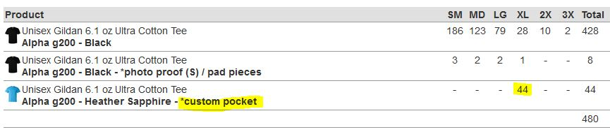

Those pocket shirts will not be accounted for by the end of the job, because we will have cut them up and applied them to the other shirts by the end of production. If the pocket shirts are not in size XL or larger, there is a chance the print will not fit accurately on the garments. Count out should put in a garment issue if shirts designated for *custom pocket is not the correct size.

*In the case of garments printed to a bolt of fabric* PO needs to create a noid line item for the bolt of fabric so that it can be received.

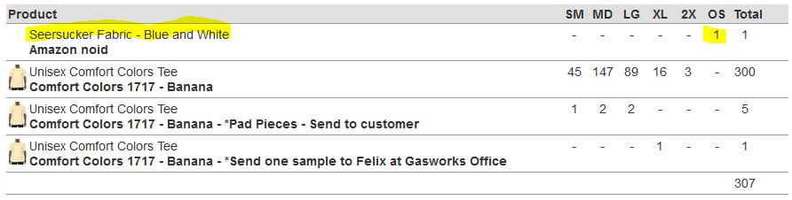

PO@ or Garments Ordering team need to alert production’s Sewing Manager, at this time, that they are not ordering the fabric needed for this job. This will allow production to get the materials needed as early as possible. Sales should be aware that fabric procurement might change the production timeline and if it is a rush job with a firm in hands, these timelines need to be clarified as early as possible. Type of fabric needed, might affect cost of the decoration as well.

Separations team will make the file for screen printing. It will need to include the dotted outline of the pockets pattern (for cutting out), the dash at the top left and right side of the pocket (signifying where to fold to cover stitch) and the center mark at the bottom of the pocket (to signal placement in the creaser). If any of these 3 marks are absent, Screen printing should alert @art and not proceed in printing until it is correct. Other marks that might be on the pocket include a dot if embroidery is being applied to the pocket before application.

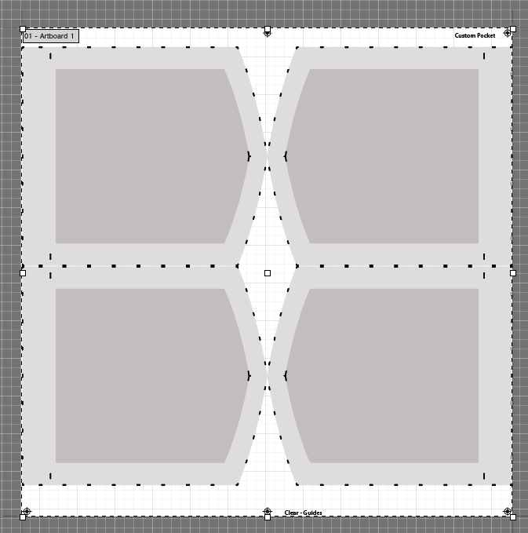

If we are not printing the pockets directly on XL Tshirts, Scheduling will need to add a fabric prep “cutting” step before screen printing. This is similar to the scheduling step in tote bag production. Sewing will cut the bolt of fabric into smaller panels of 14x14 inches. After this is complete, count out can make sure we have enough panels to complete the order and mark the fabric into the system.

Math for quantity of Pocket panels:

( **# of shirts needing pockets**) **÷** **4** **=** (**# of panels cut**)

Screen printing will need to ensure the pockets are straight with the grain of the fabric for best results. Continue to Custom Pocket Application guide for the rest of the steps.